Dublin Harbour Capital Dredging Project – Campaign no. 2 – October 2026
Dublin Port Company (DPC) intend to carry out loading and dumping at sea of dredged material arising from capital dredging as part of the Dublin Harbour Capital Dredging Project This will be the second campaign of loading/dumping to be carried out for this project.
It is intended that capital dredging will commence on 1st October 2026, subject to suitable weather conditions. The dredging campaign is scheduled to last for three to five weeks.
The areas to be dredged during the second campaign of the Dublin Harbour Capital Dredging Project is focused on the navigation channel proximate to the entrance to Alexandra Basin West; Alexandra Basin East and its berthing pockets, Oil Basin OB2/OB3 and the navigational approach channel to Riverside Berths 52/53. The maximum volume of material to be loaded and dumped is 164,000m³ in accordance with the permitted quantity in condition A.1 of the DAS Permit.
The capital dredging campaign will be undertaken by Irish Dredging Ltd a subsidiary of international dredging company Boskalis. The second dredging campaign will be carried out using a back-hoe dredger Magnor (see Figures 1). The back-hoe dredger will be accompanied by support barges and survey vessel.
The material to be dredged consists of a mixture of clay, silt, sand, gravel and cobbles. The dredged sediments will be disposed of at the existing licensed offshore disposal site located at the entrance to Dublin Bay to the west of the Burford Bank, (6.75 km from the lighthouse at the end of the Great South Wall). Sediment sampling and analysis has shown that the sediments to be dredged are suitable for disposal at sea (Class 1 uncontaminated, no biological effects likely).
The capital dredging campaign will be undertaken in accordance with the Conditions set out by a Dumping at Sea Permit and Foreshore Licence.
The Dumping at Sea Permit has been granted by Environmental Protection Agency (Permit S0033-01) and can be viewed at the following link:
Environmental Protection Agency (epa.ie)
The Foreshore Licence has been granted by the Minister of State of the Department of Housing, Local Government and Heritage and the reference number for the License is FS007164. The administration and enforcement of conditions of Foreshore Licenses since 2024 rests with the Maritime Area Regulatory Authority (MARA).
EPA and MARA have both been provided with notification regarding the upcoming dredging campaign.
DPC, in compliance with conditions set out in the Dumping at Sea Permit and Foreshore Licence will undertake an extensive monitoring programme of the dredging operations. This will include the use of Marine Mammal Observers, Marine Archaeologists and alarmed water quality monitoring buoys.
A Notice to Mariners will be issued by the Dublin Port Harbour Master and regularly updated as the capital dredging campaign proceeds. All Notice to Mariners can be located on the Dublin Port Company website
www.dublinport.ie/information-centre/notice-to-mariners
If you have any concerns with respect to this Capital Dredging Campaign (October 2026), direct contact can be made with DPC by phoning the following number during normal business hours, 01 8876000 and ask for Eamon McElroy; or by email to info@dublinport.ie. DPC will undertake to make every effort to address your concerns. Alternatively, you may wish to make direct contact with the Office of Environmental Enforcement, EPA.
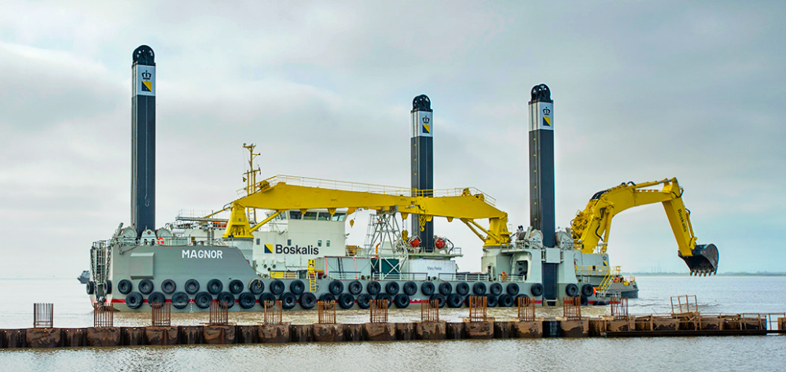
Figure 1 Back-Hoe Dredger Magnor

