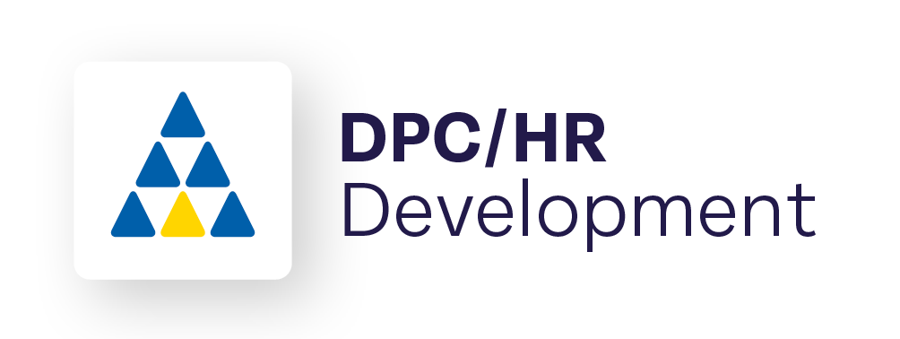

Head of Technology

Closing Date: 24 March 2023

**To apply please send a covering letter and CV to Human Resources:** [**jobs@dublinport.ie**](mailto:jobs@dublinport.ie)

**Full Role Profile available on request**

Dublin Port Company invites applications for the position of Head of Technology. The Head of Technology is responsible for the overall management of technology to ensure the delivery of efficient, reliable and secure IT services for DPC. As a priority, the Head of Technology will develop a strategic approach to support medium and long term business demands with a detailed plan to drive technology transformation.

Key to success for the Head of Technology will be the adaption of a customer centred approach focussed on the needs of the business and aligned to company strategy.

**Key Responsibilities**

* Strategic Leadership
* Stakeholder Management
* Data, Digitisation and Innovation for DPC
* Emergency Management, Security & Compliance
* People & Leadership

**The successful candidate must have:**

* Technology/IT management experience of at least five years including a range of IT disciplines such as operations, project management or systems management
* broad working knowledge of Infrastructure & Network and Applications Support
* excellent project management skills including delivery within budget
* experience in managing internal and external key relationships
* functional and technical knowledge of IT systems and technology trends
* detailed working knowledge of risk and emergency management and governance procedures
* excellent interpersonal and communications skills
* extensive knowledge of technology, the digital environment and innovation

**An advantage but not Essential:**

* Previous experience in a similar working environment
* Project management certification

**Full Role Profile available on request**