DUBLIN PORT COMPANY – TRAFFIC MANAGEMENT INFORMATION

Please be advised of the following traffic management changes to the Dublin Port Company (DPC) road network

Temporary Closures of Alexandra Road

Due to operational requirements Dublin Port will be temporarily closing security gates on Alexandra Road between No.2 Branch Road South and No.4 Branch Road South at the following times,

- Saturday 18th May 2019 between 12:00 - 18:00 hours

- Sunday 19th May 2019 between 08:00 – 21:00 hours

- Monday 20th May 2019 between 10:00 – 16:00 hours

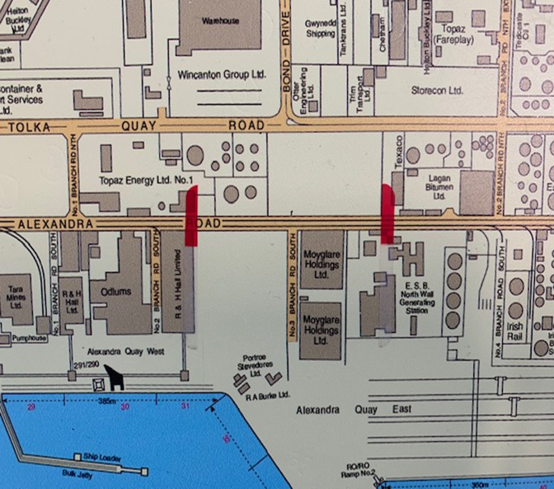

All eastbound (inbound) pedestrian or vehicular traffic on Alexandra Road will be diverted on to No.1 Branch Road North and Tolka Quay Road.

All westbound (outbound) vehicular traffic on Alexandra Road will be diverted onto No.2 Branch Road North and Tolka Quay Road. All westbound pedestrians will be required to exit Alexandra Road at Breakwater Road to Tolka Quay Road.

No.2 Branch Road South

All vehicular, pedestrian and port traffic requiring access to Ocean Pier and Alexandra Quay West will not be affected by the temporary road closures and will access/egress via No.2 Branch Road South, which is controlled by Harbour Police & Port Security personnel.

Traffic permitted to enter No.2 Branch Road South includes DPC personnel, R&H Hall staff and transporters, Dublin Stevedores Ltd personnel, Doyle Shipping Group personnel, Bord Na Mona HGV’s, Cement boat HGV tankers, Cruise related business and current ‘No.3 Branch Road South’ access control permit holders

No.4 Branch Road South

All vehicular port traffic requiring access to Alexandra Quay Container Terminal and Ocean Pier or Alexandra Quay West will do so via No.4 Branch Road South, which is controlled by Doyle Shipping Group personnel.

No pedestrian traffic is permitted to enter/exit No.4 Branch Road South.

Traffic includes all Alexandra Quay Container Terminal traffic and Doyle Shipping Group bulk cargo.

Information

Please note Variable Message Signs will be deployed to display all Alexandra Road temporary closures prior to the junction/s affected.

